**HOME PAGE**

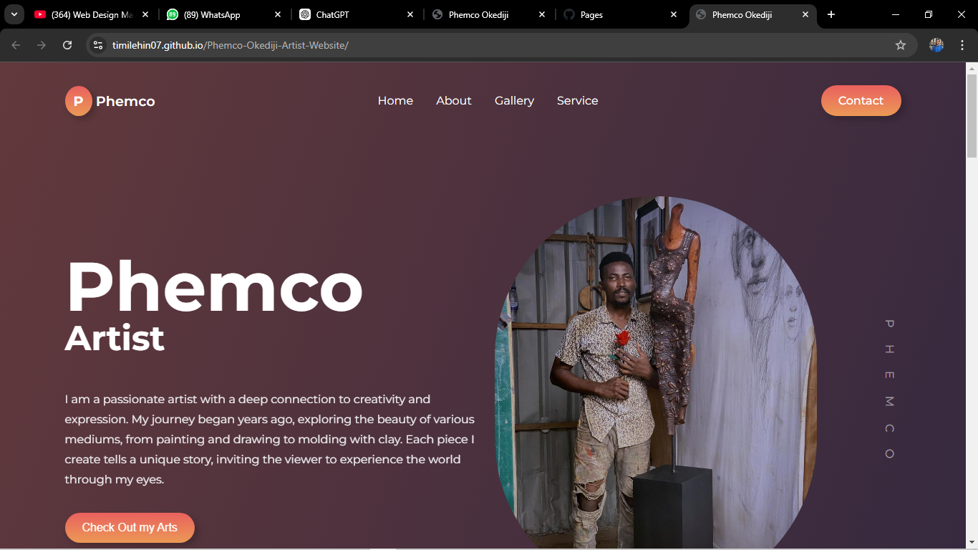

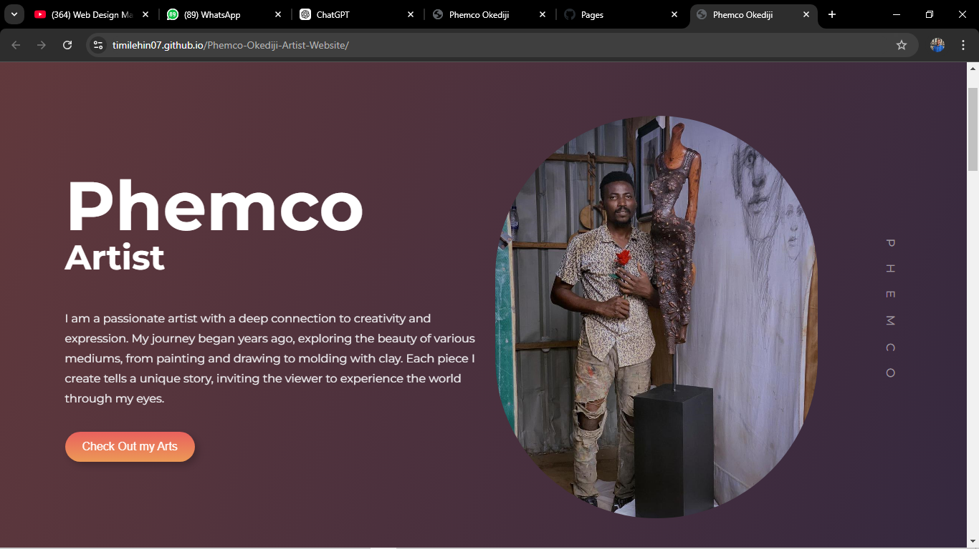

**ABOUT PAGE**

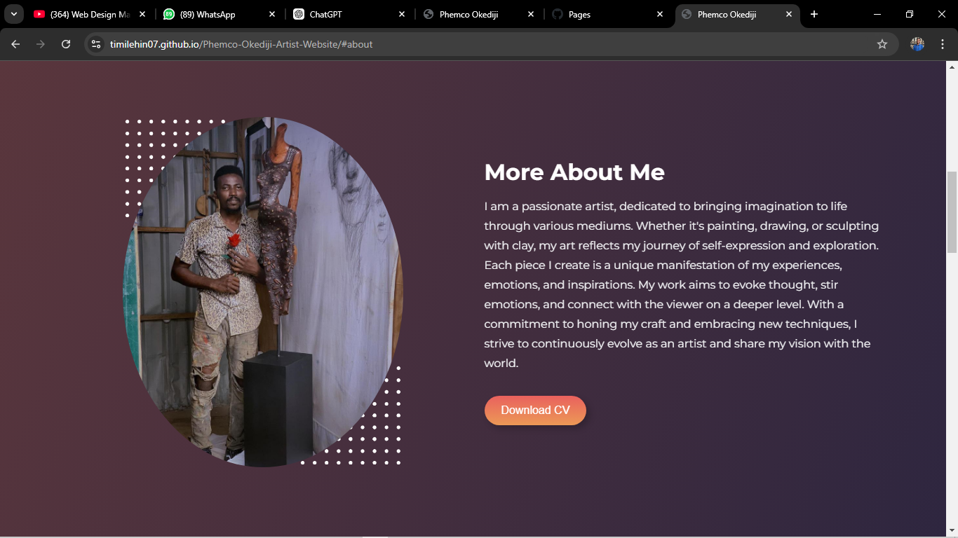

**SERVICE/SKILL PAGE**

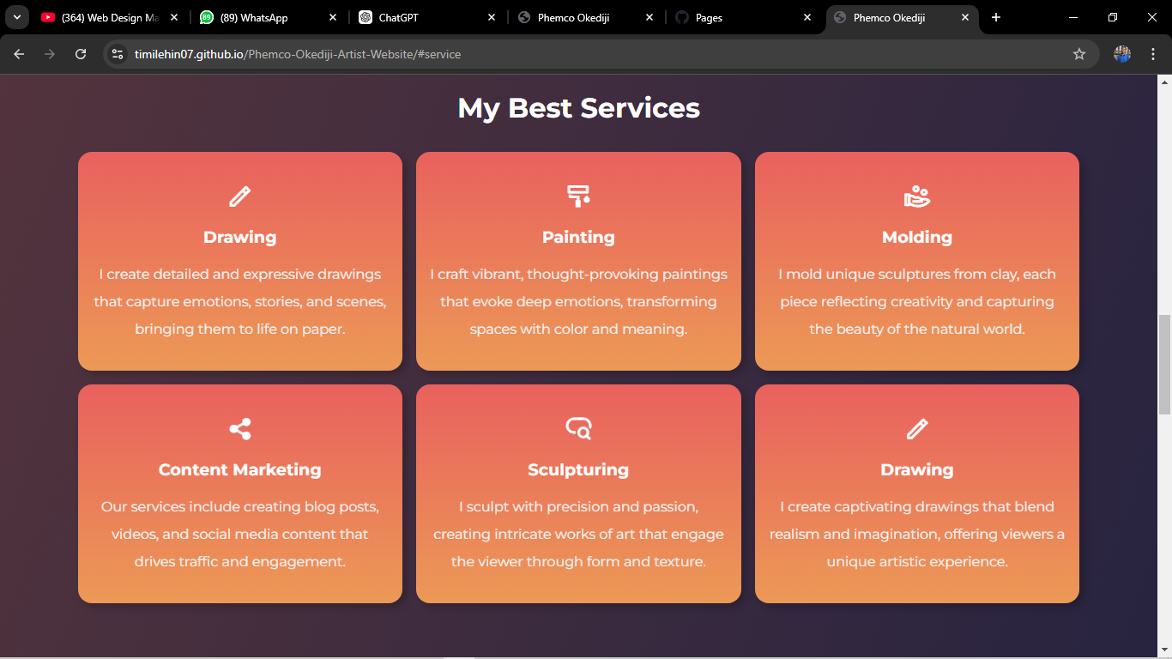

**GALLERY PAGE**

This is where we show all of your artworks…

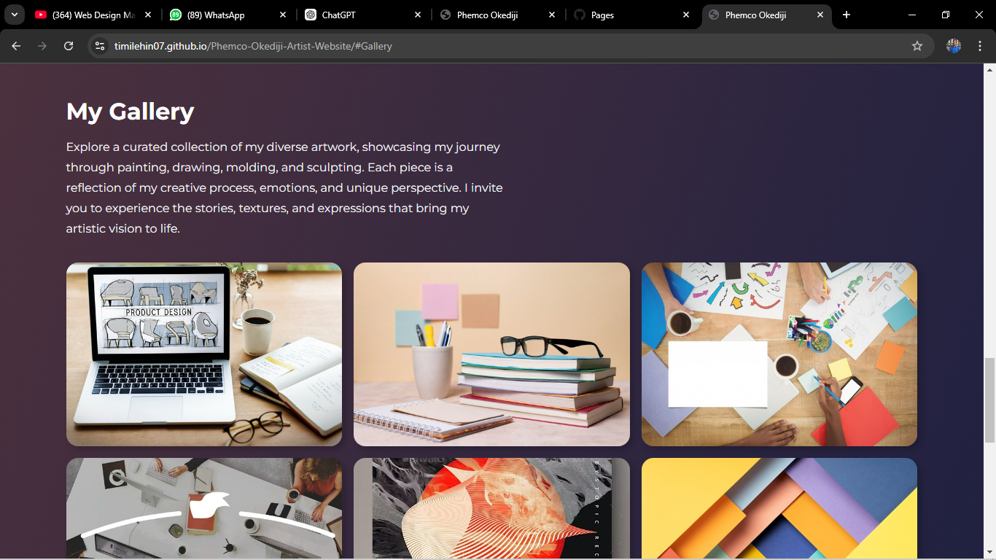

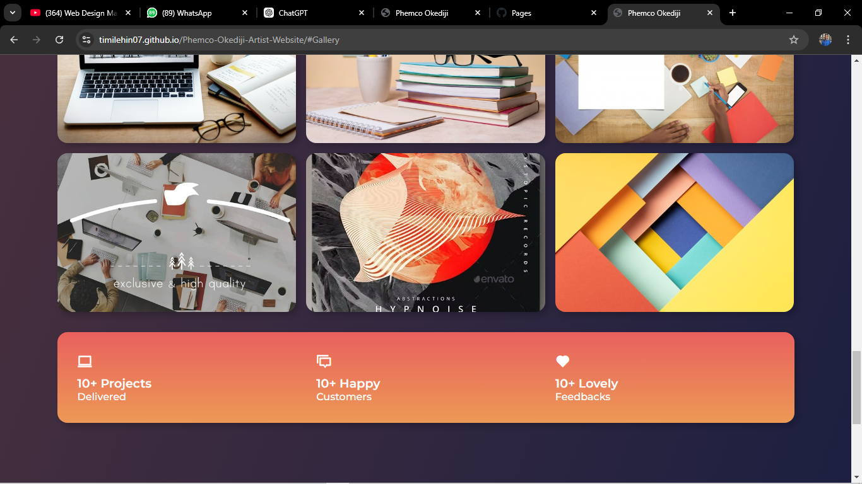

**CONTACT PAGE**

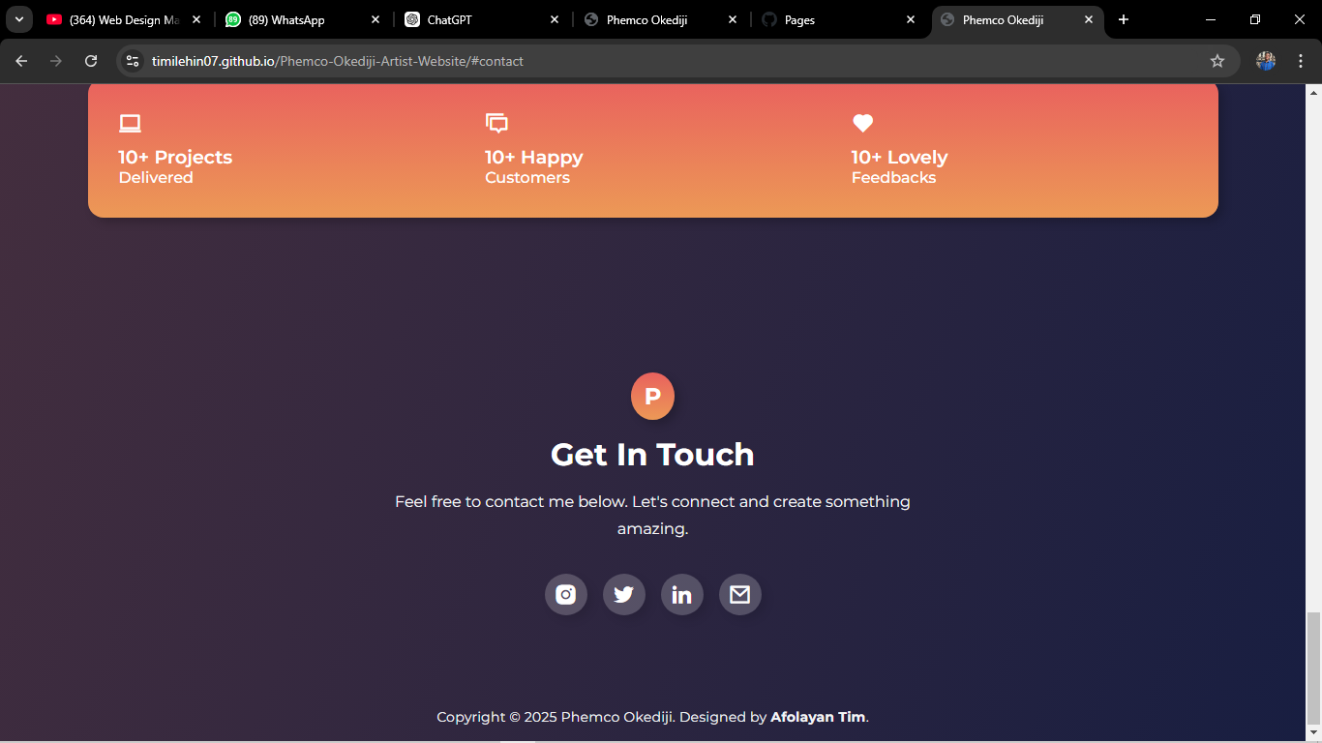

**Details I need…**

* 2 of your pictures, one for home page and the other for about page.
* How do you want your name and profession on home page?...”Phemco, Artist”
* What should I write on the home page and about you ? or is it okay like that…
* Your CV file, if you want it to be there ….
* Your services/skills, how do you want them? Details
* Your Artwork pictures….you will send these ones to my email [afolayantimi555@gmail.com](mailto:afolayantimi555@gmail.com). Or if you can send them as document on whatsapp.
* What is your email, twitter username, linkdein page for your contacts, your phone number too.. and what do you details do you want for your contact…. I already linked your Instagram page, so you can click on it and it take you to your Instagram page…
* Please let me know what else you want to add or edit or remove.